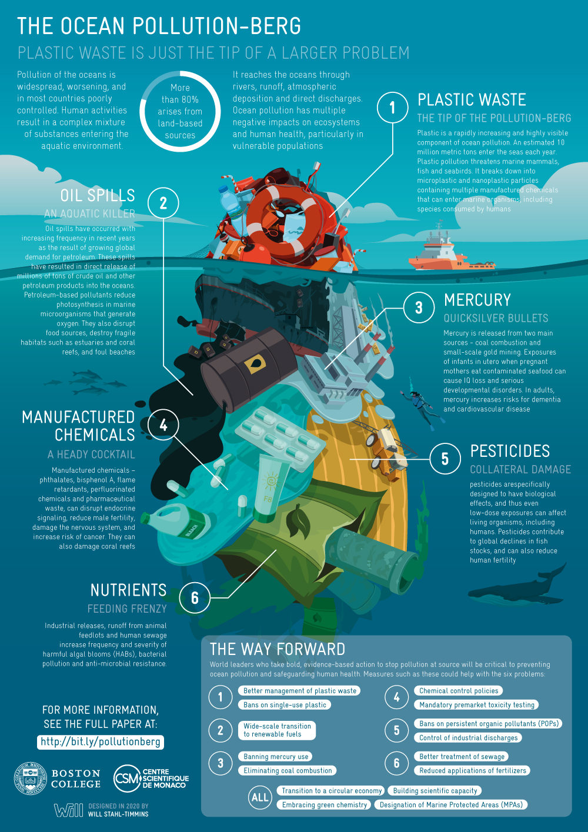

Layers of the Ocean: <https://www.noaa.gov/jetstream/ocean/layers-of-ocean>

Ocean Pollution and Marine Debris: <https://www.noaa.gov/education/resource-collections/ocean-coasts/ocean-pollution>

<https://www.nrdc.org/stories/ocean-pollution-dirty-facts>

* Brings up the concept of “ocean noise” → could be a problem that the user becomes aware of

Ghost nets: <https://oliveridleyproject.org/what-are-ghost-nets>